**Software Requirements**

**Specification**

**For**

**SM Hotels: Service Request Management System**

**Version 1.0 approved**

**Prepared by Lurenne Tangi, Kenneth Abuel**

**School of Computing and Information Technology**

**October 8, 2017**

**Copyright © 1999 by Karl E. Wiegers. Permission is granted to use, modify, and distribute this document.**

**Software Requirements Specification for <Project> Page ii**

# Table of Contents

Table of Contents ii

Revision History ii

1. Introduction 1

1.1 Purpose 1

1.2 Document Conventions 1

1.3 Intended Audience and Reading Suggestions 1

1.4 Product Scope 1

1.5 References 1

2. Overall Description 2

2.1 Product Perspective 2

2.2 Product Functions 2

2.3 User Classes and Characteristics 2

2.4 Operating Environment 2

2.5 Design and Implementation Constraints 2

2.6 User Documentation 2

2.7 Assumptions and Dependencies 3

3. External Interface Requirements 3

3.1 User Interfaces 3

3.2 Hardware Interfaces 3

3.3 Software Interfaces 3

3.4 Communications Interfaces 3

4. System Features 4

4.1 System Feature 1 4

4.2 System Feature 2 (and so on) 4

5. Other Nonfunctional Requirements 4

5.1 Performance Requirements 4

5.2 Safety Requirements 5

5.3 Security Requirements 5

5.4 Software Quality Attributes 5

5.5 Business Rules 5

6. Other Requirements 5

Appendix A: Glossary 5

Appendix B: Analysis Models 5

Appendix C: To Be Determined List 6

# Revision History

|  |  |  |  |
| --- | --- | --- | --- |
| **Name** | **Date** | **Reason For Changes** | **Version** |
| Lurenne Tangi | 10/8/2017 | Document Created, Added Purpose | 1.0 |
| Kenneth Abuel | 10/8/2017 | Added Document Conventions, Intended Audience, Product Scope, Operating Environment and Reference | 1.1 |
| Kenneth Abuel | 10/9/2017 | Minor Revisions. | 1.2 |
| Kenneth Abuel | 10/9/2017 | Minor revisions | 1.3 |
| Kenneth Abuel | 10/15/2017 | Minor Revisions | 1.4 |
| Kenneth Abuel | 11/10/2017 | Minor Revisions, Fixed Grammar Errors.  Added New Information for the functions. | 1.5 |
| Kenneth Abuel | 12/1/2017 | Minor Revisions for Features | 1.6 |

# Introduction

## Purpose

The purpose of this SRS is to provide information to the people who will involve in the service request system. In the system, it will help people especially the customers or the Hotel Guest to have a better requesting system. With this, the department will also have a better service for the hotel guest. This will be the biggest part of the system.

## Document Conventions

In this document the font has already been set at “Arial” with a font size of 11, the titles and sub titles are in bold text, the team decided to follow the format of this document. Also we did some modifications in the SRS documentation, we edited the spacing into “1.5” in order to have a better format.

## Intended Audience and Reading Suggestions

The document is intended for the following readers:

* Client – In order to have a better understanding in the system.
* Users – In the document we provided a user manual so that the user won’t have any hard time using the system
* Developers – The document can be used as a reference for the future projects of the other developers

## Product Scope

Our product the SM Hotels Service Request Management System, is a system that handles and monitors the Service Request Tickets of the SM Hotels. The system also has a function that automatically generates a ticket when a hotel guest requested a service. The team’s goal is to provide a user-friendly interface system that will help the SM Hotels to provide a better service management.

## References

Know Service. (10/8/2017). Retrieved from https://www.knowcross.com/know-service/

The Most Overlooked Hotel Management Technology. (10/8/2017). Retrieved from https://blog.capterra.com/guest-request-management-the-most-overlooked-hotel-management-technology/

Hospitality Technology Matters. (10/8/2017). Retrieved from https://info.aliceapp.com/blog/guest-request-management-the-most-under-prioritized-hotel-management-technology

# Overall Description

## Product Perspective

Currently the SM Hotels does not have yet a Service Request or Guest Request Management System they currently using Microsoft Excel to record or handle the request tickets. The SM hotels decided that they needed a Service Request system in order to have a more efficient way of providing service to their hotel guests.

<Describe the context and origin of the product being specified in this SRS. For example, state whether this product is a follow-on member of a product family, a replacement for certain existing systems, or a new, self-contained product. If the SRS defines a component of a larger system, relate the requirements of the larger system to the functionality of this software and identify interfaces between the two. A simple diagram that shows the major components of the overall system, subsystem interconnections, and external interfaces can be helpful.>

## Product Functions

The major function of the SM Hotels Service Request Management System:

* Automates the ticket generation
* List of available and non-available service employees
* A detailed view of ticket information and employee information
* Importing and Exporting of Data

## User Classes and Characteristics

* Department Supervisor / Manager – They are responsible in monitoring and handling of the service tickets
* Quality Assurance Supervisor – The supervisor is able to view the reports of the most common requested services.
* Service Employee – The Service Employee can view the tasks that are assigned to them but it is only limited on viewing.

## Operating Environment

The system will operate on the workstations at the SM Hotels, it will work on different kind of operating system. It will also work on low specification workstations; the software does not require a more advanced specification. The system will use MySQL as the database all data will be stored in it.

## Design and Implementation Constraints

The only implementation constraints that the development team are concerned about.is that the one using the SM Hotels – SRMS needs to be tech savvy because even the team designed the SRMS to be user friendly, the user still needs to understand the basic functions of what the team has developed. In order for the user to understand the SRMS the project team might conduct a training if the SM Hotels will allow it, so that the users will be able to easily figure out the SM Hotels – SRMS.

## User Documentation

<List the user documentation components (such as user manuals, on-line help, and tutorials) that will be delivered along with the software. Identify any known user documentation delivery formats or standards.>

## Assumptions and Dependencies

<List any assumed factors (as opposed to known facts) that could affect the requirements stated in the SRS. These could include third-party or commercial components that you plan to use, issues around the development or operating environment, or constraints. The project could be affected if these assumptions are incorrect, are not shared, or change. Also identify any dependencies the project has on external factors, such as software components that you intend to reuse from another project, unless they are already documented elsewhere (for example, in the vision and scope document or the project plan).>

# External Interface Requirements

## User Interfaces

The project team designed the SM Hotels – SRMS to be user friendly in order for the users to easily understand the SRMS. The SRMS uses the latest twitter-bootstrap css framework for the development of the interface and design of the SM Hotels – SRMS.

Sample Images:

Homepage: The homepage only contains the navigation bar for the specific functions of the SRMS.

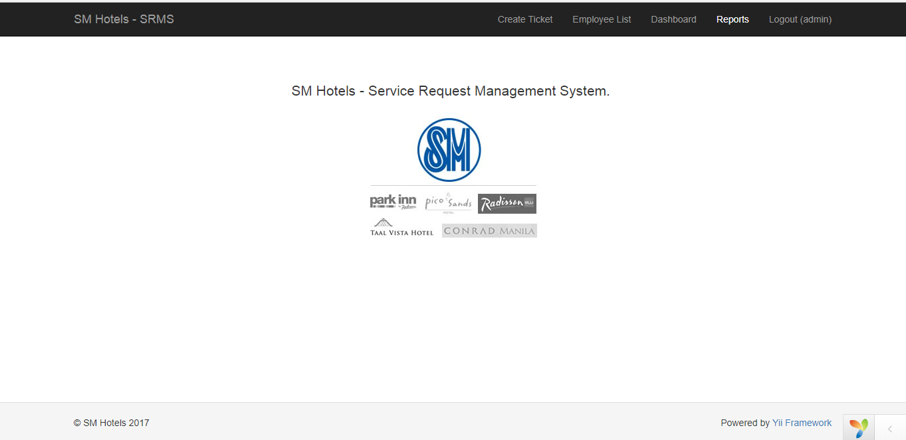

Dashboard: In the dashboard, the user will be able to monitor the requests and create new tickets if someone from the hotel guests request something.

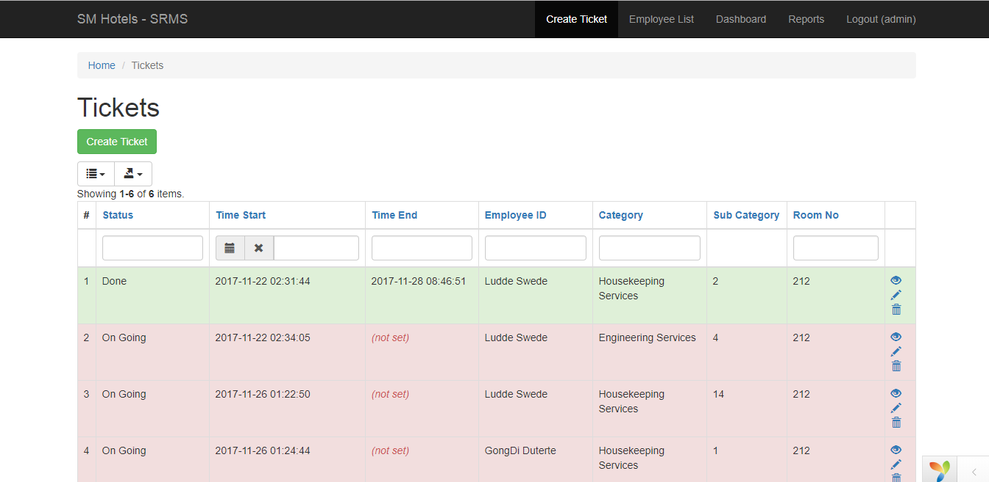

Employee Lists: This page contains who are the currently available Service Employees at the moment.

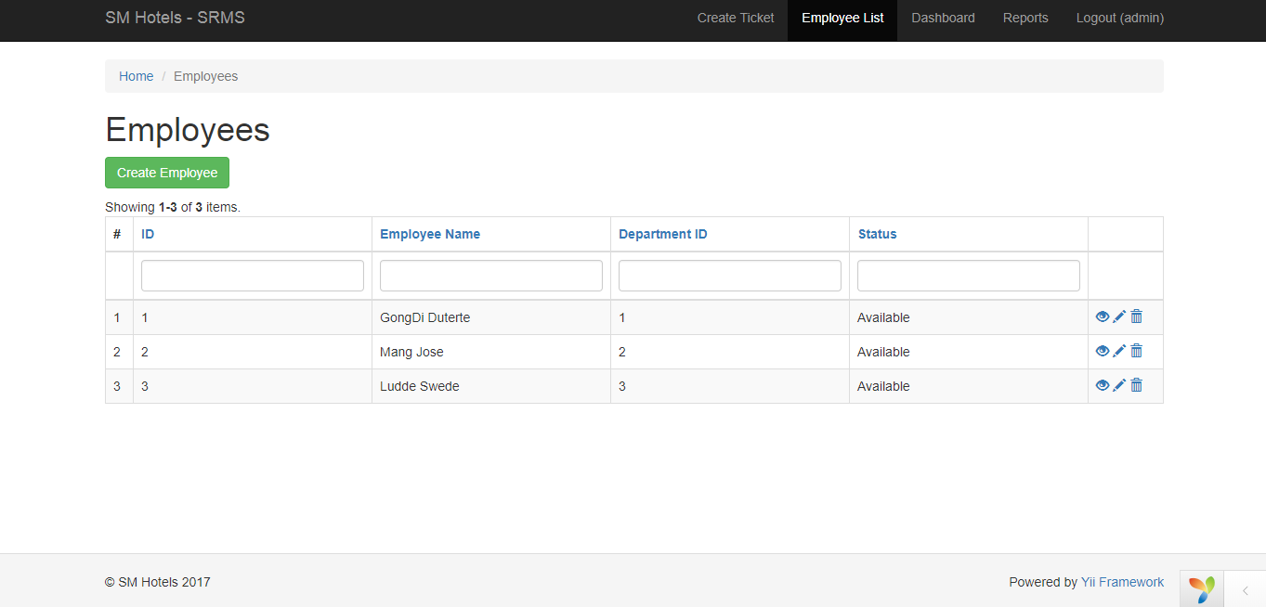

Reports: This is where the reports, charts, and graphs are created.

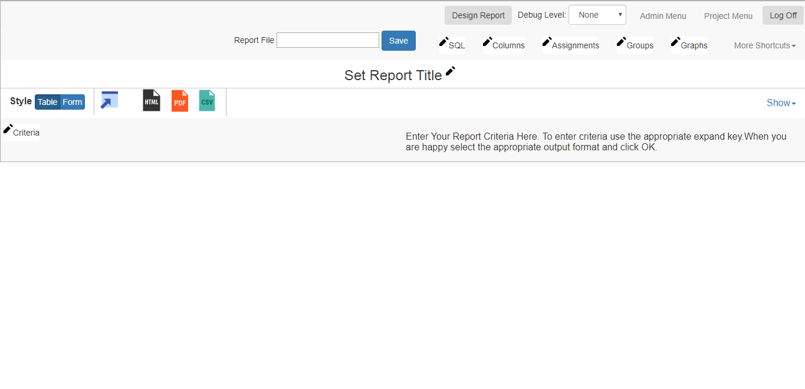

## Hardware Interfaces

A user computer is the only hardware that needs to be used in the SM Hotels – SRMS, the SRMS does not require a high spec computer just to run. The project team included the minimum or recommended computer specification for the SM Hotels – SRMS in the project document.

## Software Interfaces

The SM Hotels – SRMS uses the other following software components:

* Yii2 Framework – is a high-performance modern PHP framework best for developing both web applications and APIs.
* MySQL – The SM Hotels – SRMS uses the MySQL database for holding its data, it is one of the most popular open source databases.
* Google Chrome / Mozilla Firefox / Microsoft Edge: The SM Hotels – SRMS can run with the most commonly used web browsers in the world, the web browsers can also be used to run the pdf reports
* Microsoft Excel / Adobe Reader: Reports can be either exported and save to .csv, html, and pdf file.

## Communications Interfaces

# System Features

Here are the following features that has been developed throughout the project time.

## Automatically Generate Ticket

Description and Priority

When a hotel guest, that operator of the system creates a ticket and the system will automatically get the time when the ticket was created and it will automatically assign an employee who is currently available.

4.1.2 Stimulus/Response Sequences

<List the sequences of user actions and system responses that stimulate the behavior defined for this feature. These will correspond to the dialog elements associated with use cases.>

4.1.3 Functional Requirements

<Itemize the detailed functional requirements associated with this feature. These are the software capabilities that must be present in order for the user to carry out the services provided by the feature, or to execute the use case. Include how the product should respond to anticipated error conditions or invalid inputs.

Requirements should be concise, complete, unambiguous, verifiable, and necessary. Use “TBD” as a placeholder to indicate when necessary information is not yet available.>

<Each requirement should be uniquely identified with a sequence number or a meaningful tag of some kind.>

REQ-1:

REQ-2:

## Service Reports

Description and Priority

Any kind of data from the SRMS can be exported, the SRMS has a report functionality that get amount of data from the database.

4.1.2 Stimulus/Response Sequences

.

4.1.3 Functional Requirements

# Other Nonfunctional Requirements

## Performance Requirements

<If there are performance requirements for the product under various circumstances, state them here and explain their rationale, to help the developers understand the intent and make suitable design choices. Specify the timing relationships for real time systems. Make such requirements as specific as possible. You may need to state performance requirements for individual functional requirements or features.>

## Safety Requirements

There are no really concern about the safety requirements of the system as long as the user doesn’t accidentally delete any kind of data that the client needs.

## Security Requirements

Since we used Yii Framework for the development of the SM Hotels: SRMS, Yii’s security comes as standard, it is equipped with many security measures to help prevent the web application from attacks such as SQL Injection, Cross Site Scripting and many more.

## Software Quality Attributes

In the development of the system we used Yii, it is a high performance modern PHP framework best for developing both web applications and APIs. The system helps to ensure an extremely efficient, extensible and maintainable product. The team ensures that the system will be extremely optimized because the framework that we used was written in PHP5 that promotes clean, DRY design and encourages rapid development.

## Business Rules

<List any operating principles about the product, such as which individuals or roles can perform which functions under specific circumstances. These are not functional requirements in themselves, but they may imply certain functional requirements to enforce the rules.>

# Other Requirements

The other requirements that we needed was the proper terms that we needed to be labeled in our system that’s why we asked our client for proper naming or terms that the SM Hotels is using.

# Appendix A: Glossary

<Define all the terms necessary to properly interpret the SRS, including acronyms and abbreviations. You may wish to build a separate glossary that spans multiple projects or the entire

organization, and just include terms specific to a single project in each SRS.>

# Appendix B: Analysis Models

<Optionally, include any pertinent analysis models, such as data flow diagrams, class diagrams, state-transition diagrams, or entity-relationship diagrams.>

# Appendix C: To Be Determined List

<Collect a numbered list of the TBD (to be determined) references that remain in the SRS so they can be tracked to closure.>